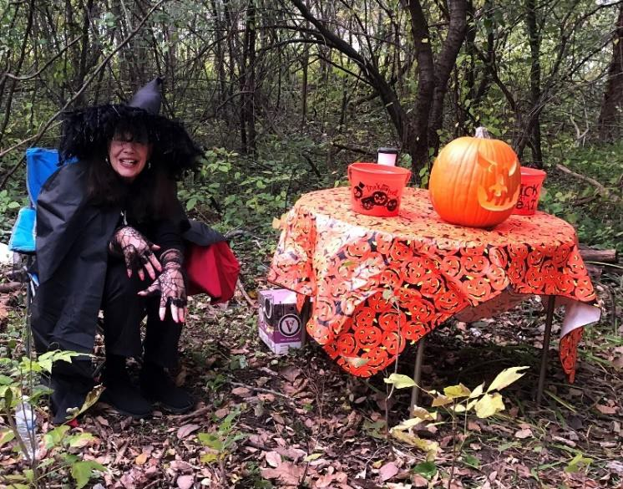
For candy stations Dress up (or not)
(Yes, you can donate candy)

SAVE THE DATE
Horseshoe Lake Corporation
5th Annual Trick or Treat on the Trail Lakeshore Drive Nature Trail Saturday, October 28, 5:00 to 6:30 PM
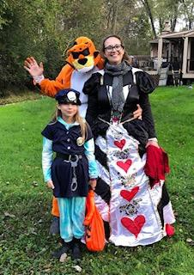
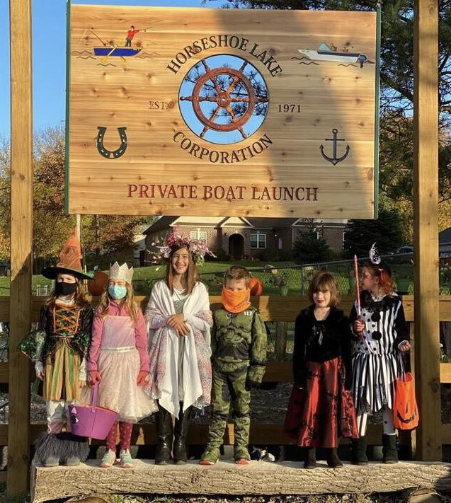
Contact Laura Misko 734-775-9883 or L_misko@hotmail.com; Mike Grosh 734-646-6931 or mikeundefined87@gmail.com; or Elaine Harper 734-808-1010 or dancemoma06@gmail.com
Sponsored by the Horseshoe Lake Corporation Special Events Committee.

